Enterprise Program Management office (EPMO)
GuessLow
Customer User Manual
September, 2026
Version: 1.0

Revision History
Version | Date | Author | Description
1.0 | 02/09/26 | Tony Solomon | Initial creation

Document Control
Document Information | Remark
Document Owner | Nib International Bank S.C - EPMO
Issued Date | 02/09/26
File Name | GuessLow - Customer User Manual

Document History
Version | Date | Change
V.1.0 | 02/09/26 | Initial creation

Document Author
Name | Position | Department | Sign
Tony Solomon | Junior Software Engineer | EPMO
Aliy Umer | Junior Software Engineer | EPMO

Document Reviewer
Name | Position | Department | Sign
Gebreab Dagne | Principal Project Control and QA Officer | EPMO

Document Validator
Name | Position | Department | Sign
Fiseha Tesfaye | EPMO – Senior Director | EPMO

Table of Contents
Revision History ii
Document Control iii
Table of Contents iv
Acronyms vi
1. Introduction 1
1.1 Purpose 1
1.2 Who This Manual Is For 1
1.3 What GuessLow Is 1
2. How Winning Works 2
2.1 A Worked Example 2
2.2 Why You Cannot See Other People's Amounts 2
3. Getting Started 3
3.1 Opening GuessLow 3
3.2 The Screen Header 3
4. The Home Screen 5
5. Browsing Auctions 9
6. Reading an Auction Page 10
7. Placing a Bid 13
7.1 Step One — Choose Your Amount 13
7.2 Step Two — Confirm and Accept the Terms 14
7.3 Step Three — Place the Bid 16
7.4 If a Bid Is Not Accepted 18
8. Following Your Bids 19
9. When an Auction Closes 21
9.1 Checking the Result for Yourself 22
9.2 When Nobody Wins 22
10. Claiming a Prize 23
10.1 How to Claim 24
10.2 What Happens Next 25
11. When an Auction Is Run Again 26
11.1 You Are Never Charged Twice 26
11.2 Being Told About It 26
12. Your Profile and Language 27
12.1 Changing Your Display Name 27
12.2 Changing the Language 28
12.3 Getting Help 28
13. Frequently Asked Questions 29
Approvals 29

Acronyms
Term | Definition
Bid amount | The figure you choose and submit for an auction.
Bid service fee | The small, non-refundable charge for each bid you place.
Claim window | The period in which a winner must claim their prize.
ETB / Br | Ethiopian Birr, the currency all amounts are shown in.
Lowest unique bid | The lowest amount that only one person submitted.
Mini-app | GuessLow as it appears inside the super app.
Re-auction | A fresh round of an auction that closed without a winner.
Super app | The banking application you open GuessLow from.
Unique amount | An amount that exactly one person submitted.

1. Introduction

1.1 Purpose
This manual explains how to use GuessLow as a customer. It covers finding an auction, placing a bid, following the result and claiming a prize. No technical knowledge is needed.

1.2 Who This Manual Is For
Anyone who opens GuessLow from the super app to take part in an auction. If you manage auctions on behalf of the bank, please refer to the GuessLow Administrator User Manual instead.

1.3 What GuessLow Is
GuessLow is an auction where premium items are won for a fraction of what they are worth. You do not bid the highest amount to win. You bid the lowest amount that nobody else has chosen.
You pay a small bid service fee for each bid you place. The amount you bid is not charged when you place it. Only the winner pays their winning amount, in addition to the fee.

2. How Winning Works
GuessLow is a lowest unique bid auction. The winner is the person holding the lowest amount that nobody else submitted.
The lowest bid does not automatically win. Only the lowest unique bid wins.

2.1 A Worked Example
Imagine an auction receives these bids:
Amount | How many people chose it | Is it unique?
1.00 Br | Two people | No
2.00 Br | One person | Yes
3.00 Br | Two people | No
4.00 Br | One person | Yes

Only 2.00 Br and 4.00 Br were chosen by exactly one person. The lower of those two wins, so 2.00 Br takes the prize — not 1.00 Br, even though it is lower, because two people chose it.
Remember. Bidding as low as possible is not a winning strategy on its own. Everyone else is trying to bid low too, so the very lowest amounts are usually chosen by more than one person. You are guessing which low amount the others will avoid.

2.2 Why You Cannot See Other People's Amounts
While an auction is running, you can see your own bid amounts and nobody else's. Everyone else's appear hidden. This is deliberate: if you could see which amounts had been taken, you would know exactly which amount would win, and the auction would not be fair.
All amounts are revealed once the auction closes and its result is published.

3. Getting Started

3.1 Opening GuessLow
GuessLow opens from inside the super app. There is no separate registration form and no password to remember — the super app identifies you, and GuessLow uses your registered phone number as your account.
You can browse the home page, the auction list and any individual auction without signing in. You will be identified automatically before you place your first bid, view your bids, or claim a prize.
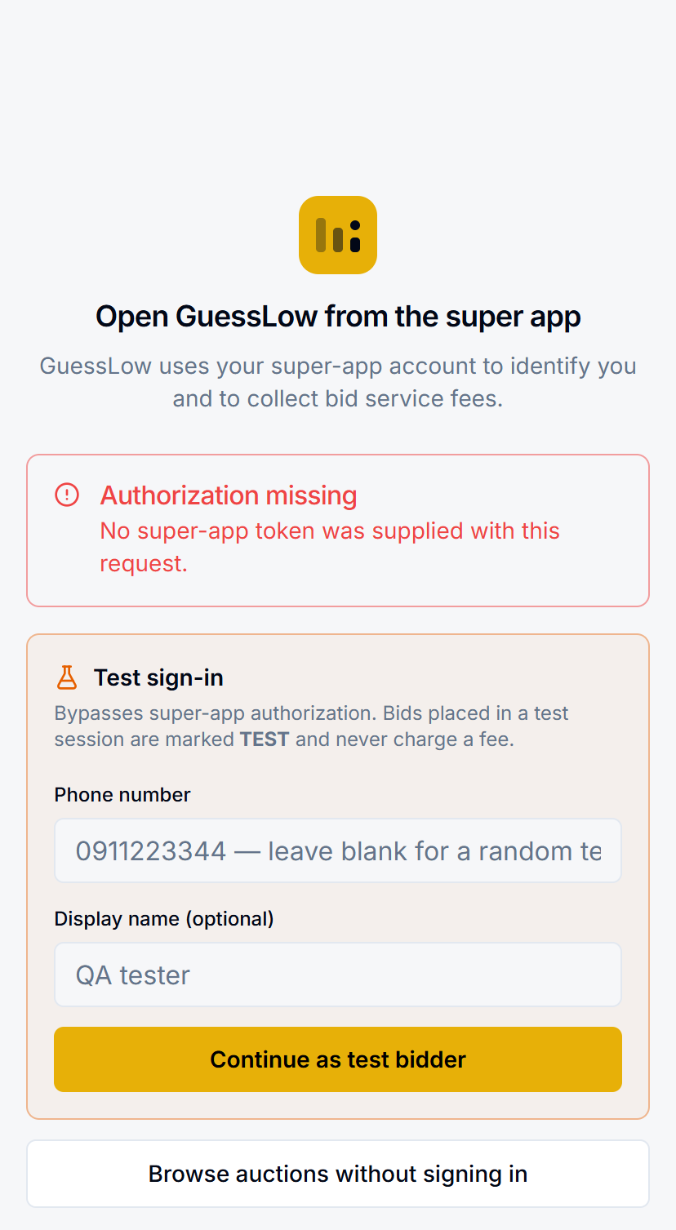
Figure 3.1: The GuessLow entry screen. In normal use the super app signs you in automatically and you go straight to the page you tapped.

3.2 The Screen Header
The header stays with you throughout the app:
- En / አማ — switches the app between English and Amharic.
- Gavel icon with a number — how many bids you have placed.
- Person icon — opens your profile.

4. The Home Screen
The home screen introduces the current auctions and shows what other customers have won. Reading down the page you will find:
Section | What it shows
Start Bidding Now | Takes you straight to the list of auctions.
Live counters | How many auctions are running, how many bids have been placed, and how many winners there have been.
Categories | Tap a category to see only those items.
Featured Items | Auctions the team has highlighted.
Recent winners | Real results — the item, the winner and the winning amount.
How It Works | A four-step summary and the worked example.

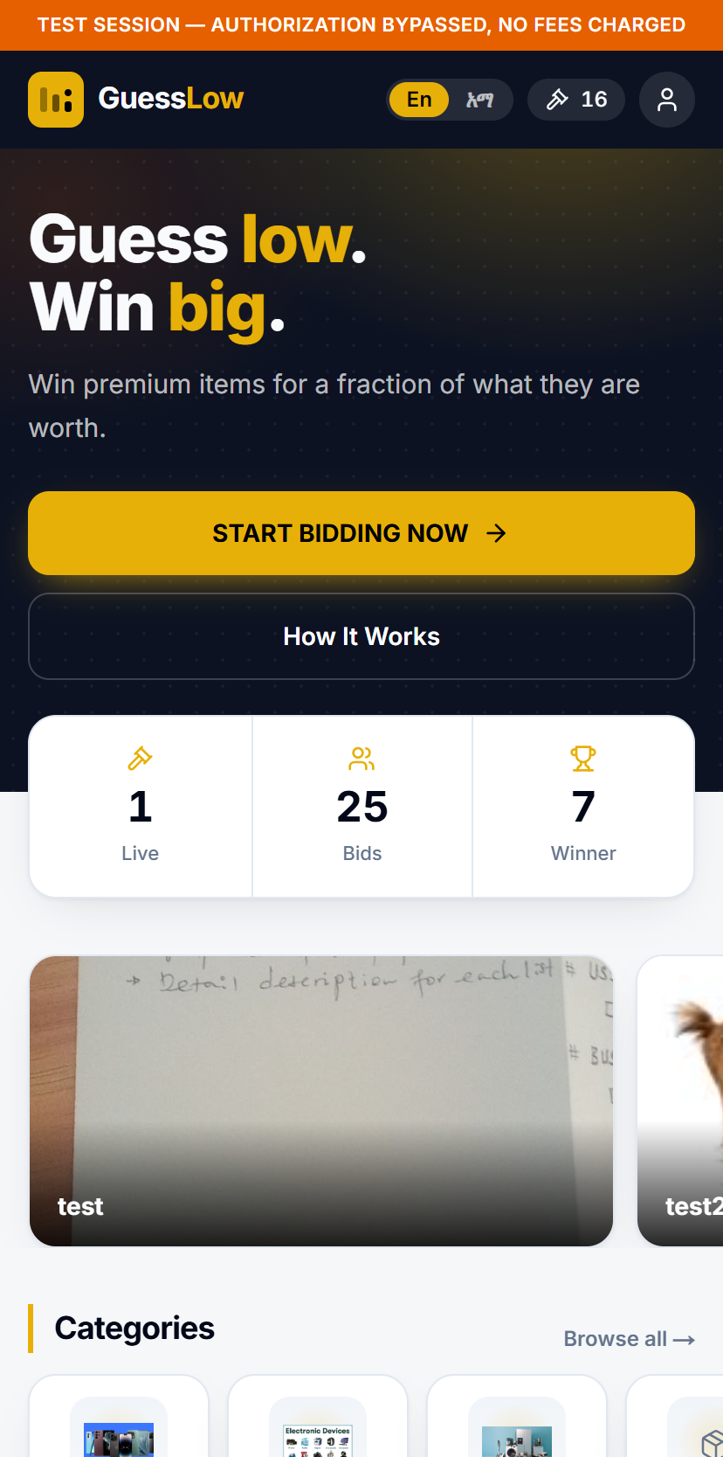
Figure 4.1: The top of the home screen — the opening banner, the live counters and the category tiles.
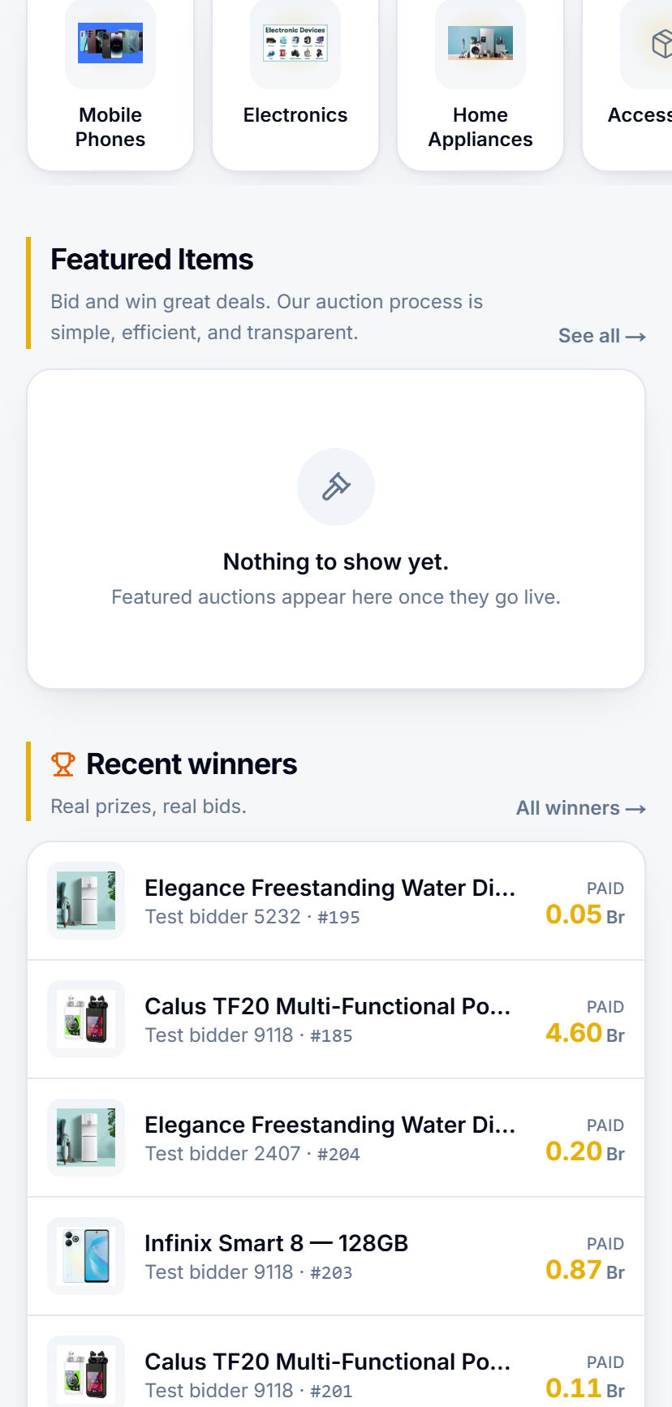
Figure 4.2: Featured items, and the recent winners board showing real results and the amounts that won them.
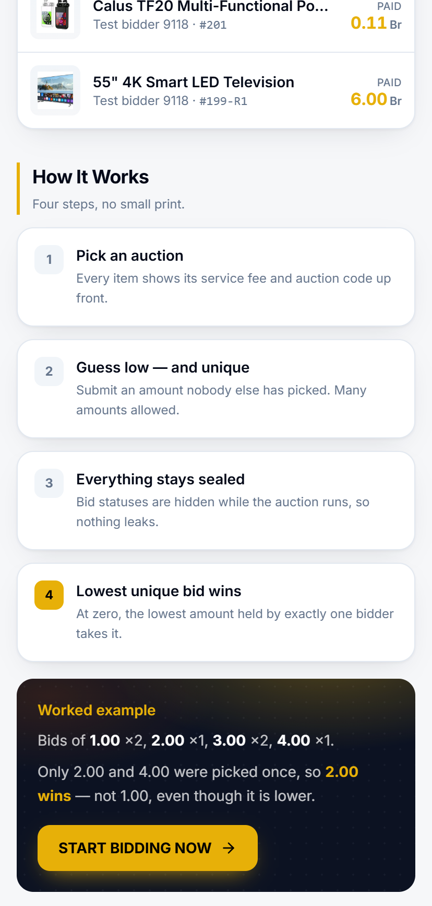
Figure 4.3: How It Works, closing with the worked example.

5. Browsing Auctions
Select Start Bidding Now, or the gavel icon, to see every auction.
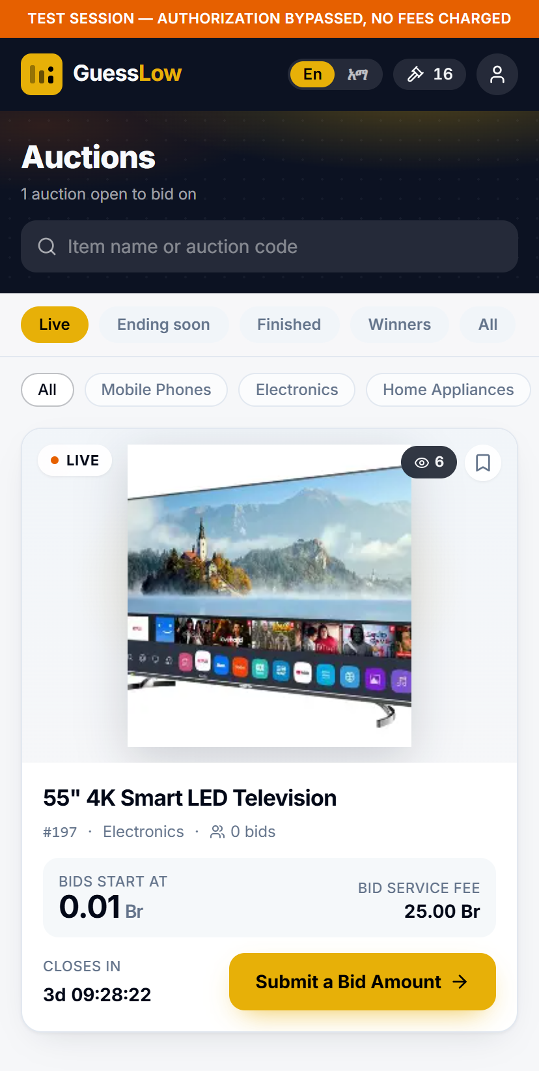
Figure 5.1: The auction list. Each card shows the item, its status, the time remaining and the bid service fee.
Tap any card to open that auction.

6. Reading an Auction Page
The auction page carries everything you need in order to choose an amount.
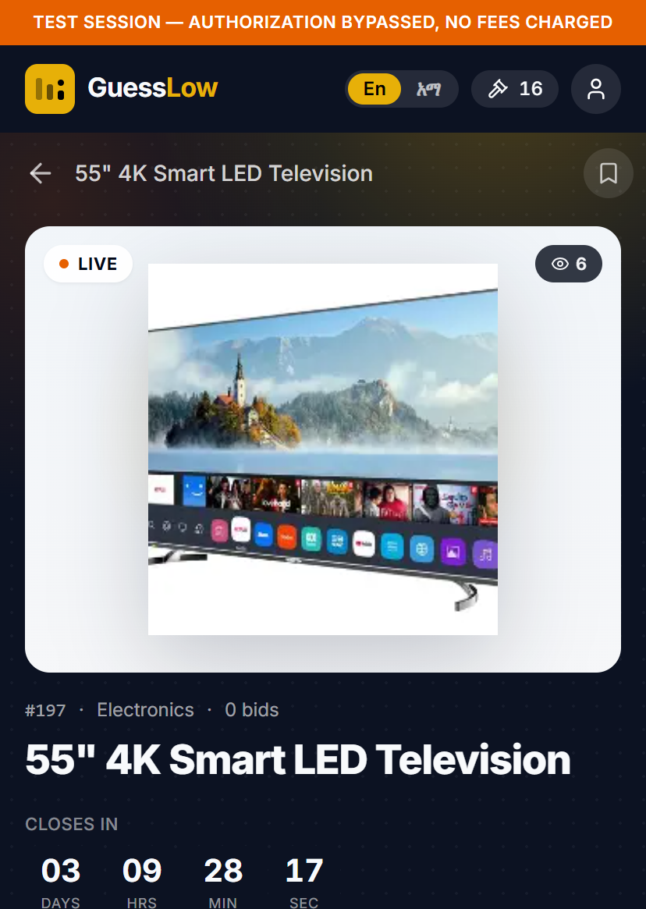
Figure 6.1: The top of a running auction — the item, and the countdown to the moment bidding closes.
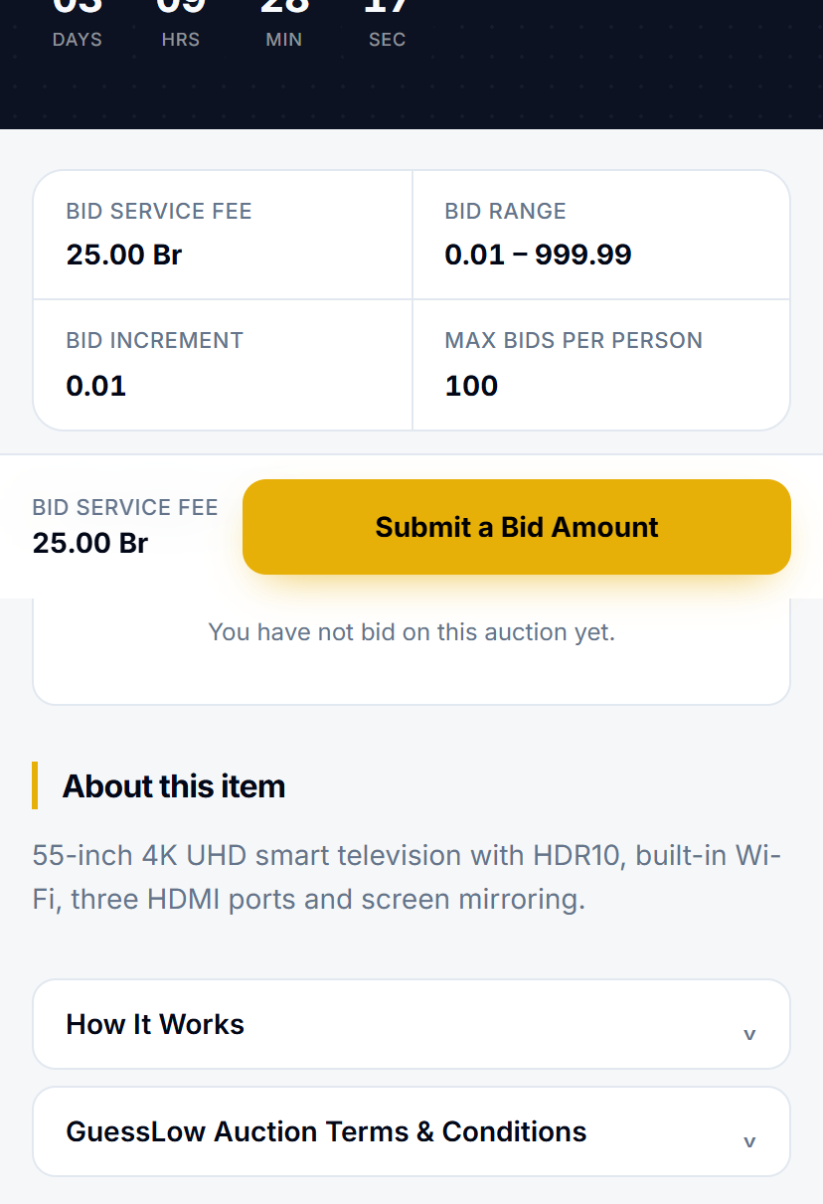
Figure 6.2: The rules for this auction, with Submit a Bid Amount fixed to the bottom of the screen.
What you see | What it means
Closes in | A live countdown to the moment bidding closes.
Bid service fee | What each bid costs you. It is taken from your super-app wallet.
Bid range | The lowest and highest amount you are allowed to submit.
Bid increment | The step your amount must land on. With a 0.01 increment, 4.75 is allowed and 4.752 is not.
Max bids per person | How many bids you may place on this auction.
Your bids | How many of your allowance you have used so far.

Further down the page you will find a description of the item, a short How It Works explanation, and the terms and conditions that apply to this particular auction.
The bar fixed to the bottom of the screen repeats the fee and holds the Submit a Bid Amount button, so it is always within reach.

7. Placing a Bid
Placing a bid takes three steps. Nothing is charged and nothing is registered until you complete the last one.

7.1 Step One — Choose Your Amount
- Open the auction you want to enter.
- Select Submit a Bid Amount. A panel slides up from the bottom of the screen.
- Type your amount, or use the − and + buttons to move one increment at a time.
- Select Submit a Bid Amount inside the panel to continue.

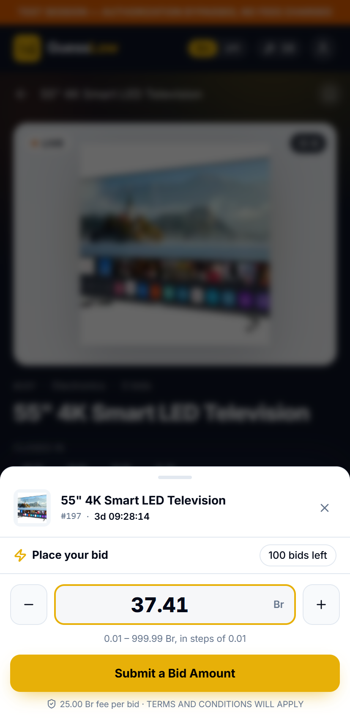
Figure 7.1: Choosing an amount. The line under the field repeats the allowed range and step, and the pill on the right shows how many bids you have left.

7.2 Step Two — Confirm and Accept the Terms
A confirmation screen appears. This is the last point at which nothing has happened yet.
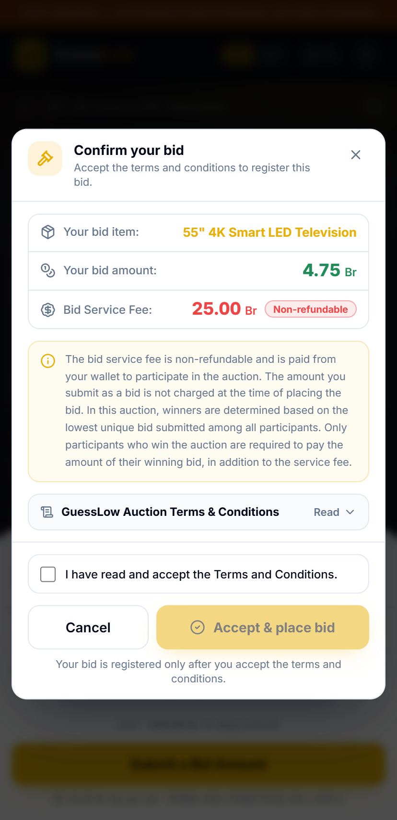
Figure 7.2: The confirmation screen. Accept & place bid stays inactive until you tick the box.
Check the item and the amount, and read the note about the fee. It confirms that the bid service fee is non-refundable, and that the amount you bid is not charged now — only the winner pays their winning amount, in addition to the fee.
- Read the terms and conditions.
- Tick I have read and accept the Terms and Conditions.

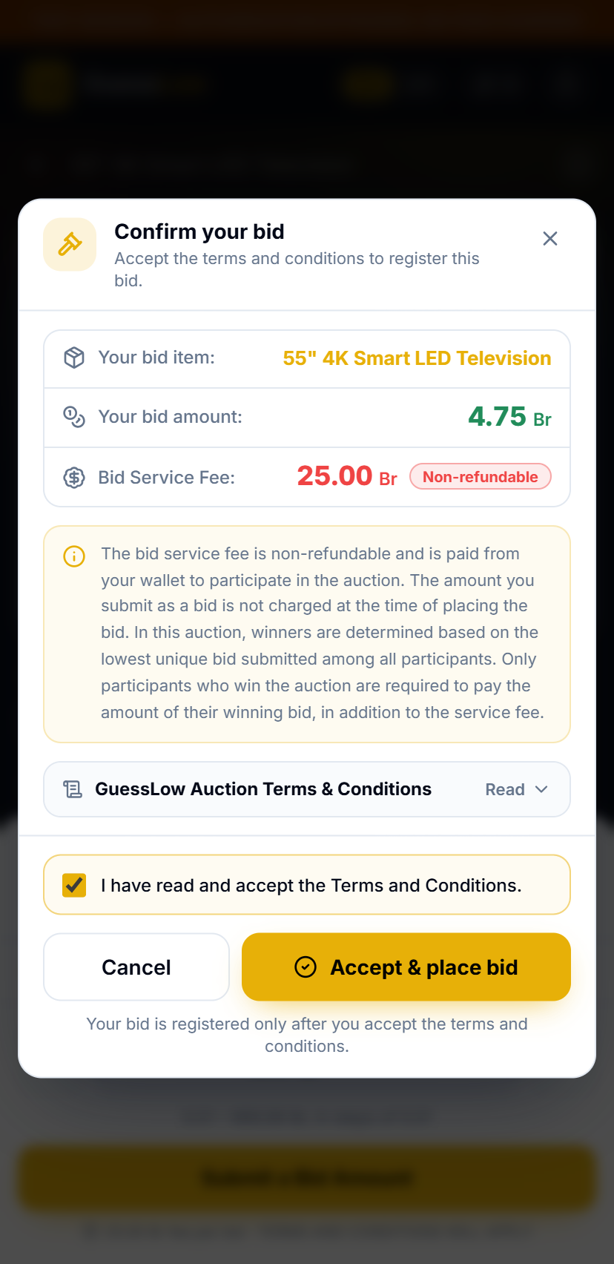
Figure 7.3: With the box ticked, the Accept & place bid button becomes active.

7.3 Step Three — Place the Bid
Select Accept & place bid. The bid service fee is taken from your super-app wallet, and the screen shows that your payment is being confirmed.
Important. A bid only counts once its fee has been confirmed. The screen updates by itself when that happens — you do not need to do anything.

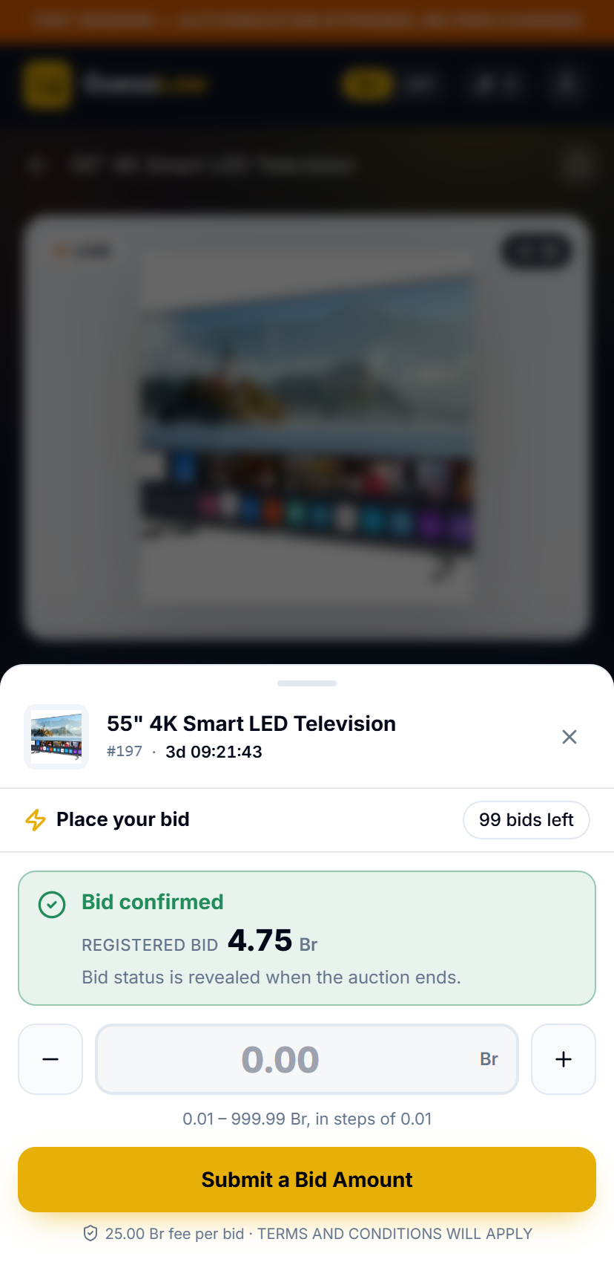
Figure 7.4: The bid is registered. Your remaining allowance drops by one and the field clears, ready for another bid.
Notice the line that reads "Bid status is revealed when the auction ends." Your bid is safely in, but you are not told whether it is currently unique — and neither is anybody else.
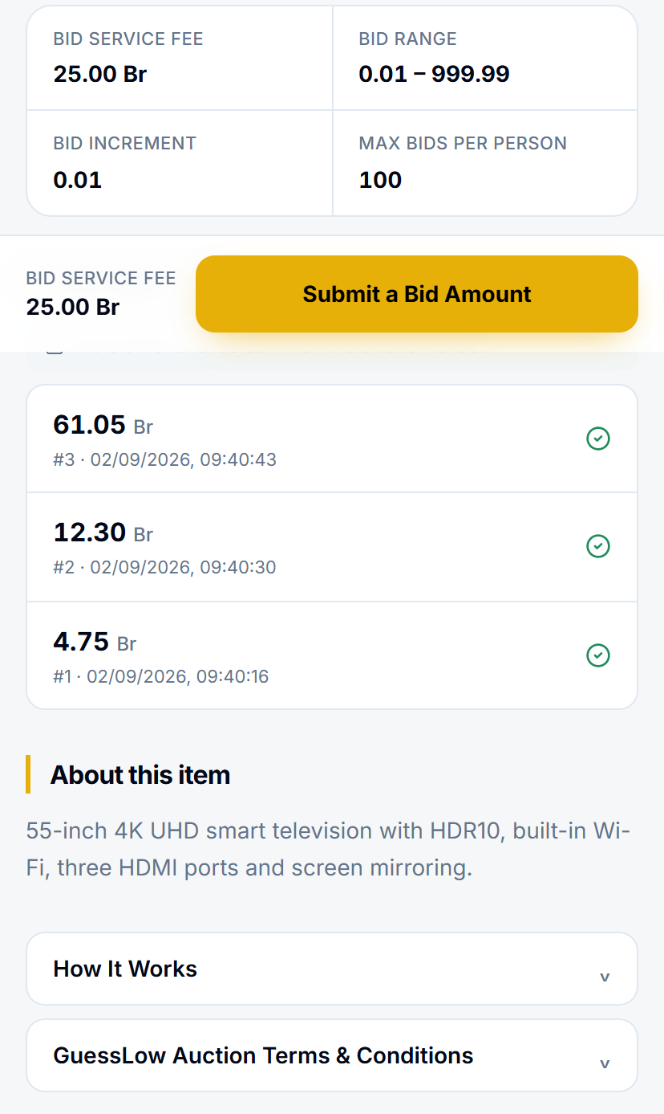
Figure 7.5: Back on the auction page, Your bids shows how many of your allowance you have used, with your own amounts listed underneath.

7.4 If a Bid Is Not Accepted
GuessLow will tell you why a bid was not accepted. The usual reasons are:
- The terms and conditions were not accepted.
- The auction has already closed.
- The amount is outside the allowed range, or does not sit on the increment.
- You have already used that exact amount on this auction.
- You have reached the maximum number of bids for this auction.
- You are bidding again too quickly — wait a moment and try again.
- The auction is open to invited participants only, and your number is not on the list.

8. Following Your Bids
Select My Bids from your profile, or the gavel icon in the header, to see everything you have entered.
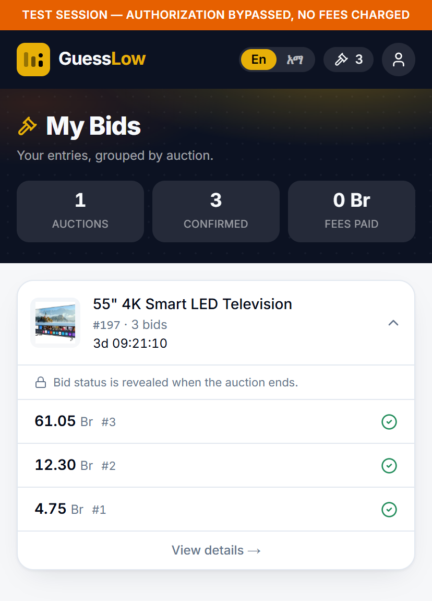
Figure 8.1: My Bids groups your entries by auction. The padlock line is a reminder that bid status stays sealed until the auction ends.
The banner at the top counts the auctions you are taking part in, the bids you have placed and the fees you have paid. Each auction appears as a card you can open or collapse.
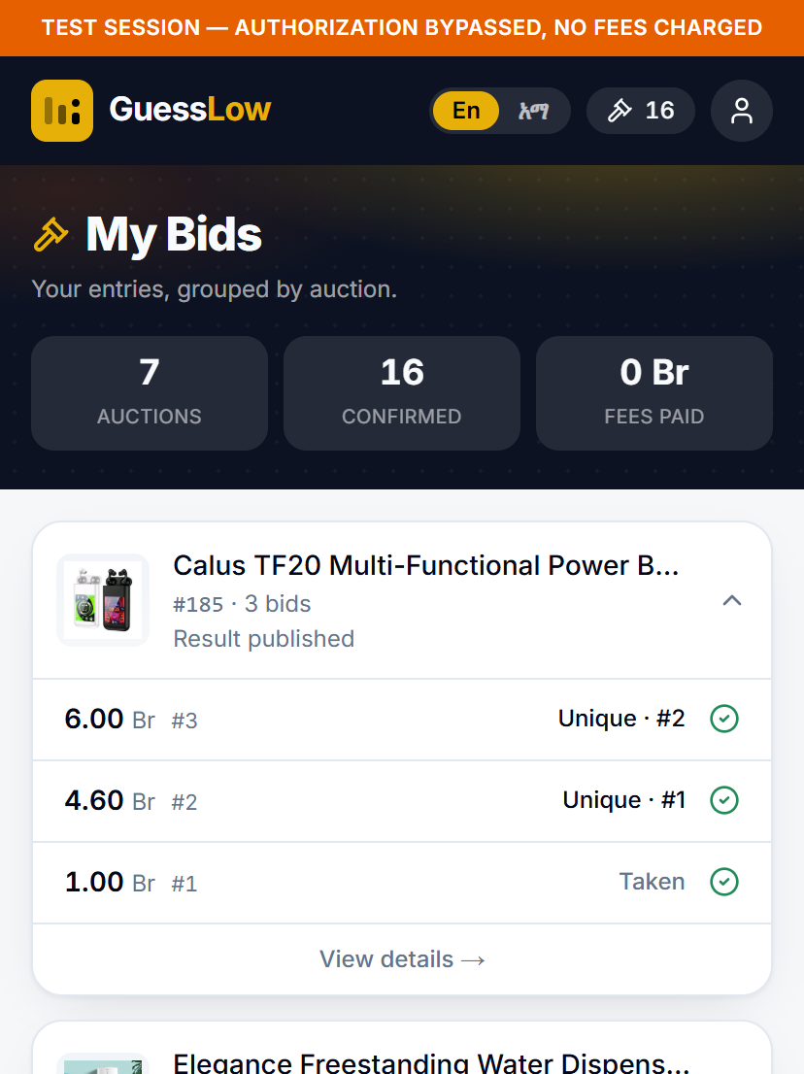
Figure 8.2: How My Bids looks before you have entered your first auction.

9. When an Auction Closes
When bidding closes, GuessLow works out the result and publishes it. Every amount is then revealed.
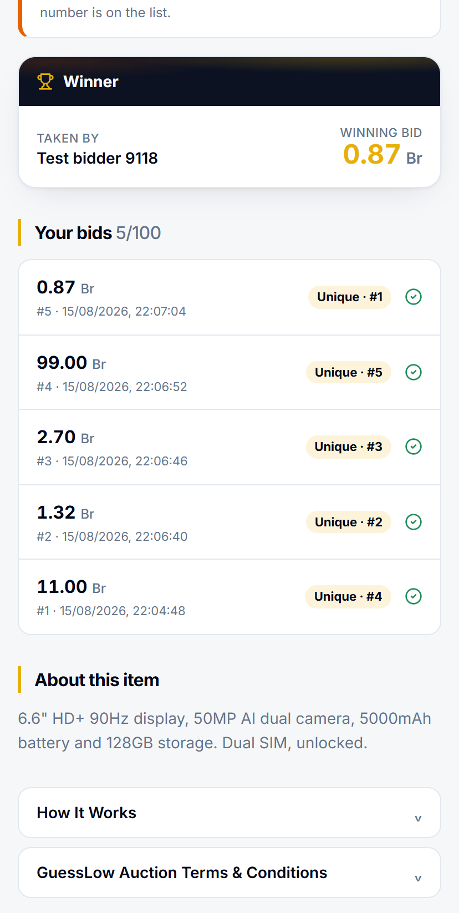
Figure 9.1: A closed auction. The winner and the winning bid are published, and each of your own bids now shows whether it was unique and where it ranked.
Three things appear that were not there while the auction was running:
- The Winner panel — who took the item, and the winning amount.
- Your own bids, each marked with whether it was unique and where it ranked.
- The full result, so you can see how the outcome was reached.

9.1 Checking the Result for Yourself
After an auction closes, GuessLow can publish a list of every amount that was bid and how many bids landed on each one. It lets you confirm for yourself that the amounts cheaper than the winning one were each chosen by more than one person, and that the winning amount was chosen by only one.

9.2 When Nobody Wins
Sometimes an auction closes without a winner. This happens when every amount was chosen by more than one person, or when too few bids were placed for a fair result. The item is not awarded, and the auction may be run again.

10. Claiming a Prize
If you win, you are notified by SMS and a claim window opens. Claim your prize from the Wins screen before the deadline shown.
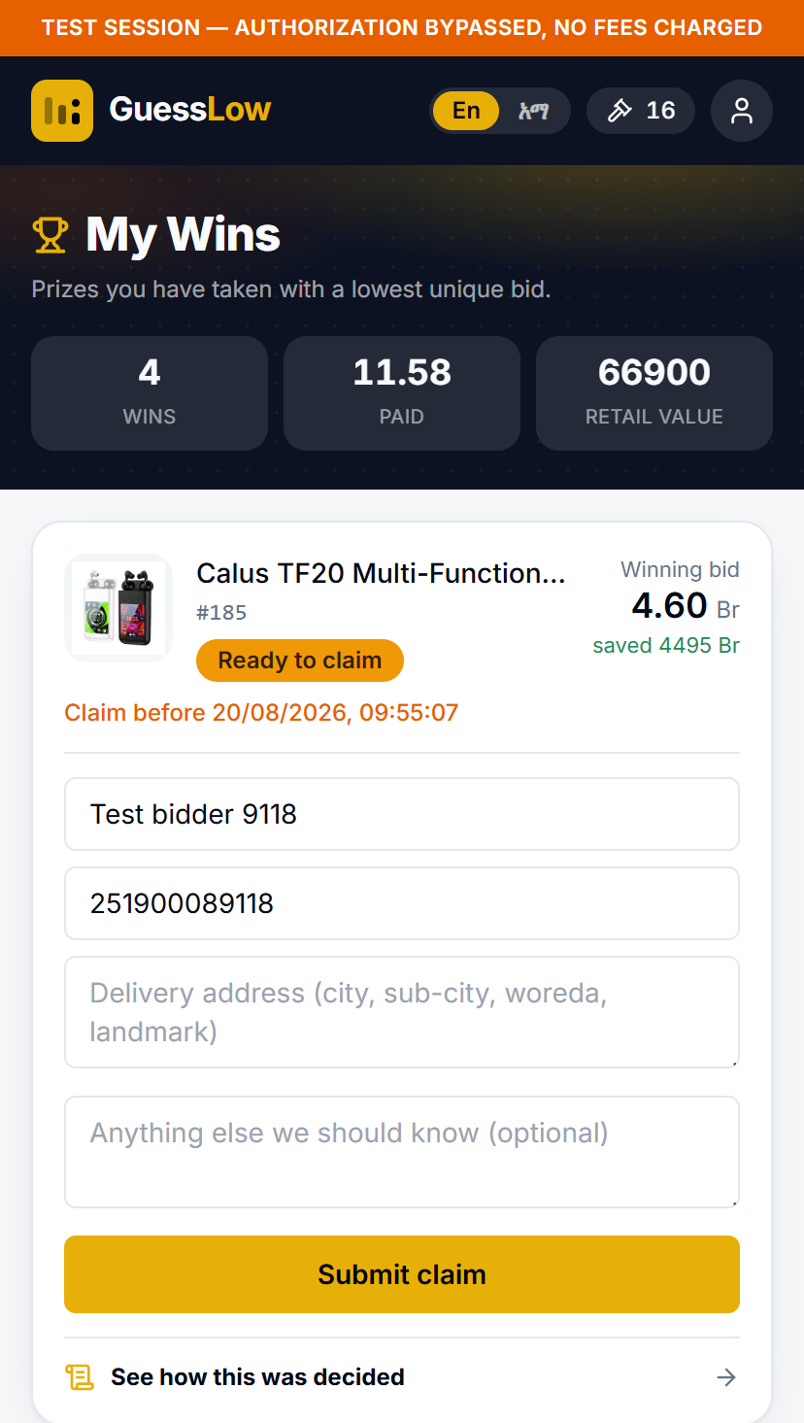
Figure 10.1: My Wins. The banner totals your wins, what you paid and the retail value of what you took.
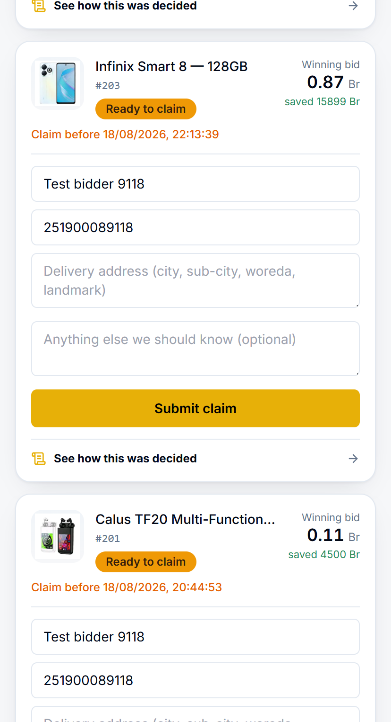
Figure 10.2: Each win card shows the winning bid, how much you saved, the claim deadline in orange, and the claim form itself.

10.1 How to Claim
- Open Wins from your profile.
- Find the card for the prize you have won.
- Check that your name and phone number are correct.
- Enter your delivery address — city, sub-city, woreda and a nearby landmark.
- Add anything else the team should know. This is optional.
- Select Submit claim before the deadline shown in orange.

Do not miss the deadline. If the claim window closes before you submit your claim, the prize is forfeited and may be offered to the runner-up.

10.2 What Happens Next
Once you submit your claim, the bank's team verifies your details and arranges delivery. Your claim moves through these stages:
Stage | What it means
Awaiting claim | You have won. The claim window is open and waiting for you.
Claimed | Your claim has been received.
Verified | Your details have been checked and accepted.
Delivered | Your prize has been handed over.

The link marked "See how this was decided" opens the auction result, so you can check the ranking that awarded you the prize.

11. When an Auction Is Run Again
An auction that closes without a winner can be run again rather than cancelled. The new round is a fresh auction for the same item, and it carries a code that extends the original — for example 199 becomes 199-R1.

11.1 You Are Never Charged Twice
Every bid you already paid for in that auction becomes a free bid in the new round.
If you paid for 5 bids and then place 8 in the re-run, the first 5 are free and only 3 are charged. Those 3 then carry into a third round if there is one. Across the whole series you only ever pay for the largest single round you took part in.

11.2 Being Told About It
Everyone from the previous round receives an SMS when a new round opens. It tells you that the auction is being run again, how many free bids you have, and from which bid a fee starts again. If the new round is not open to you, you are told that instead.

12. Your Profile and Language
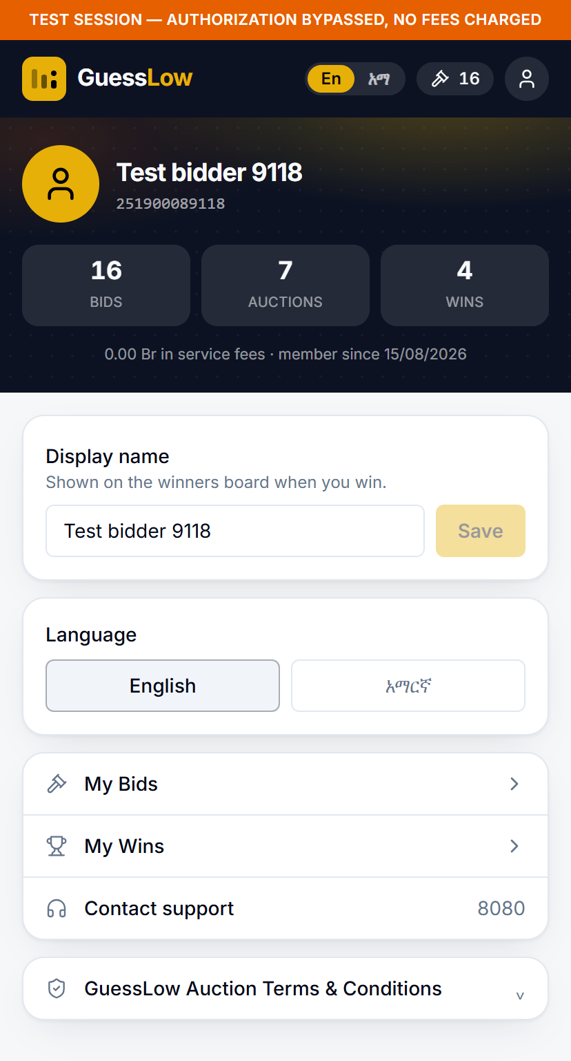
Figure 12.1: Your profile, with your totals, your display name and the language switch.
The banner shows your phone number, how many bids you have placed, across how many auctions, how many you have won, the fees you have paid and when you joined.

12.1 Changing Your Display Name
Your display name is what appears on the winners board when you win.
- Open your profile.
- Type the name you would like to use.
- Select Save.

12.2 Changing the Language
GuessLow is available in English and Amharic. Use the language buttons on your profile, or the En / አማ switch in the header. Your choice is remembered.
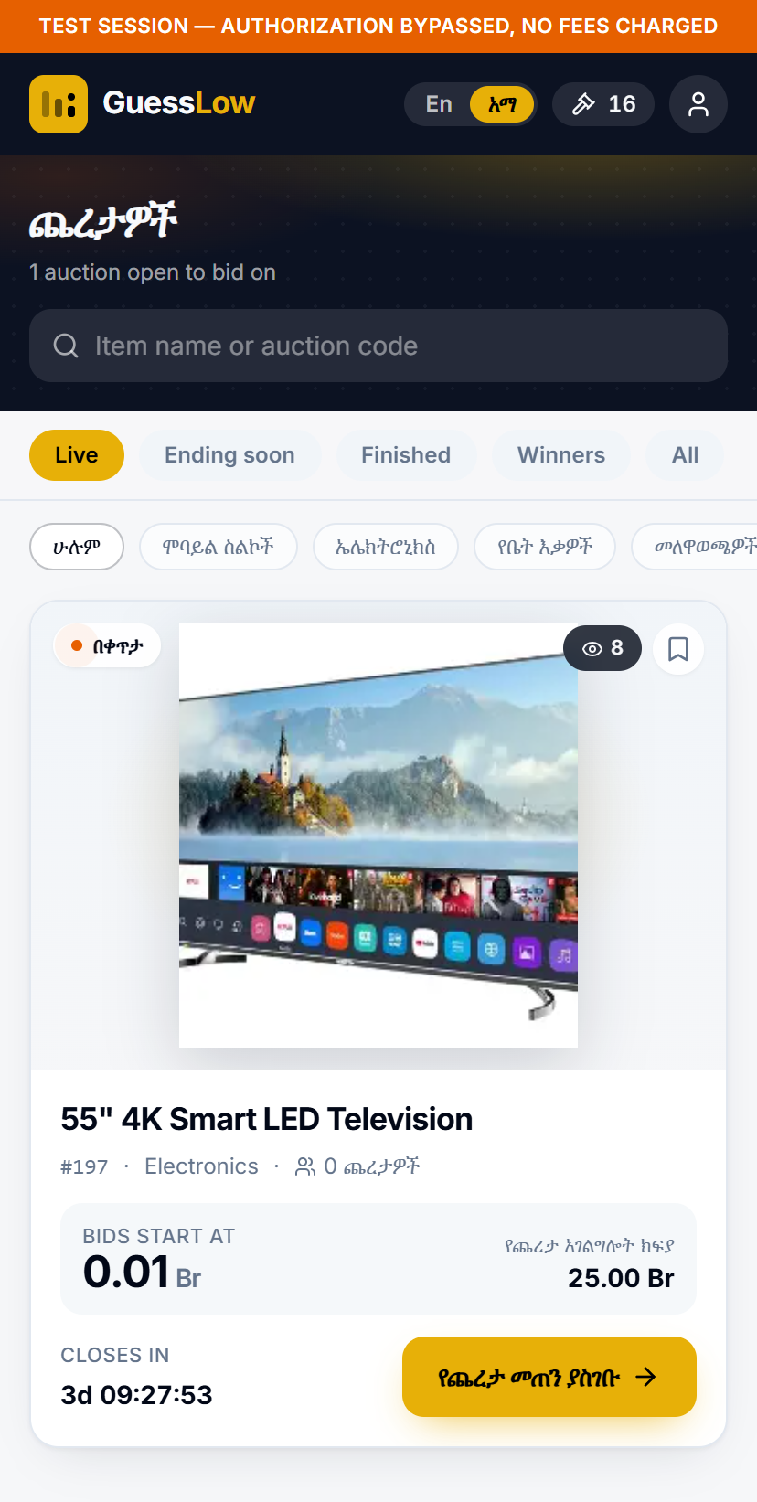
Figure 12.2: The auction list in Amharic.

12.3 Getting Help
Your profile also lists a support telephone number, along with shortcuts to My Bids and My Wins and the full terms and conditions.

13. Frequently Asked Questions
Question | Answer
Does the lowest bid always win? | No. The lowest unique bid wins — the lowest amount that only one person chose.
How much does it cost to take part? | You pay the bid service fee shown on the auction for each bid you place. It is not refundable.
Am I charged the amount I bid? | Only if you win. The winner pays their winning amount in addition to the fee.
Can I see what other people have bid? | Not while the auction is running. All amounts are revealed once it closes.
Can I bid the same amount twice? | No. Each of your bids on an auction must be a different amount.
How many times can I bid? | Up to the maximum shown on the auction page. Your remaining allowance is displayed as you bid.
Can I cancel or change a bid? | No. A bid is final once it has been placed and confirmed.
How will I know if I have won? | You receive an SMS, and the auction appears under Wins in the app.
What if I do not claim in time? | The prize is forfeited and may be offered to the runner-up, so claim before the deadline.
What happens if nobody wins? | The item is not awarded. The auction may be run again, and the bids you paid for carry over free of charge.

Approvals

Approvers Name Date Signature
EPMO Director: ______________________ _______________ __________
Project Owner: ______________________ _______________ __________

